3-1 Review Name:__________________________________
- Study the diagram of an electromagnet. Describe each component and its role in the circuit.
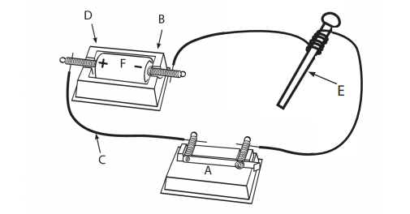
- ___________________________________________________________________
- ___________________________________________________________________
- ___________________________________________________________________
- ___________________________________________________________________
- ___________________________________________________________________
- ___________________________________________________________________

- How can you determine if electricity is flowing in a circuit? ____________________________________________________________________________________________________________________________________________
- Which Light Bulb will light? Explain your answer.
______________________________________________________________________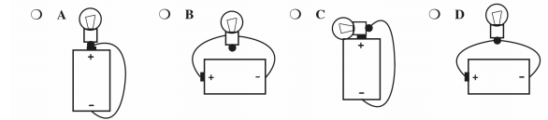

- Why does a compass needle change position when electricity is flowing through a circuit? ____________________________________________________________________________________________________________________________________________
- List and describe the factors that can affect the strength of an electromagnet. ________________________________________________________________________________________________________________________________________________________________________________________________________________________________________________________________________________________
- Draw a simple circuit. Label the components. Describe the energy transfers from one component to the next, beginning and ending at the power source.

